

**CSA06 - DESIGN AND ANALYSIS OF ALGORITHMS**

**CAPSTONE PROJECT REPORT**

**PROJECT TITLE**

**“Implementing Graph Algorithms for Social Network Analysis”**

**REPORT SUBMITTED BY**

**192321185 D. Pavithra**

**192372370 A. Reddy Sulochana**

**TABLE OF CONTENTS**

|  |  |  |
| --- | --- | --- |
| **S.NO** | **CONTENT** | **PAGE NO.** |
| **1** | **Problem Statement** | **1** |
| **2** | **Introduction** | **2** |
| **3** | **Literature Survey** | **3** |
| **4** | **Architecture Diagram** | **4** |
| **5** | **Flow Chart Diagram** | **5** |
| **6** | **Pseudocode** | **6** |
| **7** | **Implementation** | **7** |
| **8** | **Results** | **8** |
| **9** | **Complexity Analysis** | **9** |
| **10** | **Conclusion** | **10** |
| **11** | **Future Work** | **11** |

**1. Problem Statement**

In social networks, understanding the relationships and influences between individuals is essential for applications such as community detection, influencer identification, and recommendation systems. Given a social network represented as a graph, where nodes represent users and edges represent connections (e.g., friendships or followers), the goal is to analyze this network using graph algorithms to extract meaningful insights. The task involves implementing various graph algorithms to achieve specific analysis objectives, such as detecting communities, identifying key influencers, and finding shortest paths between users. In today’s digital world, social networks play a vital role in connecting individuals, communities, and information. With millions of users and connections, analyzing social networks for meaningful insights requires efficient computational approaches. Graph algorithms, which represent users as nodes and connections as edges, provide a powerful way to explore network structure, relationships, and influential members.

* **Objectives:**
  + Develop algorithms to detect communities within the network.
  + Identify key influencers based on graph centrality measures.
  + Calculate the shortest paths between selected users.
  + Analyze network properties such as connectivity and clus

**1**

**2. Introduction**

Social network analysis (SNA) applies graph theory to the study of social structures, where individuals or groups are represented as nodes, and the interactions or relationships between them are represented as edges. SNA has applications across many fields, including sociology, psychology, marketing, and epidemiology, to model and analyze human behaviors and relationships within networks. With the rapid growth of online platforms and communication channels, analyzing vast social networks has become crucial for identifying trends, understanding influence dynamics, and predicting future behaviors.

Key objectives of this project include:

* **Identifying community structures** that represent subgroups of users with common interests or connections.
* **Determining influential individuals** within a network through centrality measures, which identify nodes based on their connectivity or reach within the network.
* **Analyzing connectivity patterns** to reveal degrees of separation, weak points, and potential paths for information spread.

Dynamic programming and other advanced graph algorithms, such as Breadth-First Search (BFS) for shortest-path detection and modularity-based clustering for community detection, are critical in providing these insights. This study will contribute to both theoretical understanding and practical applications of social network analysis, helping researchers and businesses make data-driven decisions based on network insights.

**2**

### ****3.Literature Survey****

Graph algorithms applied to social network analysis intersect with multiple fields, each contributing techniques for effective analysis:

* **Graph Theory**: Foundational algorithms, such as Depth-First Search (DFS) and BFS, provide the basis for traversing and exploring network structures. These methods are particularly effective for tasks like finding connected components and calculating distances.
* **Community Detection**: Algorithms like Girvan-Newman, Louvain, and modularity-based clustering help identify cohesive subgroups within networks. These algorithms are crucial for understanding network segmentation and targeting specific communities.
* **Centrality Measures**: Degree, betweenness, closeness, and eigenvector centralities quantify the importance or influence of nodes. Centrality measures have widespread applications, from marketing (influencer identification) to public health (disease-spreading nodes).
* **Big Data Processing**: With the increasing scale of social networks, algorithms optimized for large datasets, such as Apache Giraph, GraphX, and distributed versions of community detection algorithms, are becoming essential for handling millions of nodes and edges.

**Key References**

1. *Girvan, M., & Newman, M. E.* (2002). "Community structure in social and biological networks." *Proceedings of the National Academy of Sciences*.
2. *Freeman, L. C.* (1977). "A set of measures of centrality based on betweenness." *Sociometry*.
3. *Aggarwal, C. C., & Wang, H.* (2011). "A survey of clustering algorithms for graph data." *Springer*

### ****3****

### ****4.Architecture Diagram with Hardware Influence****

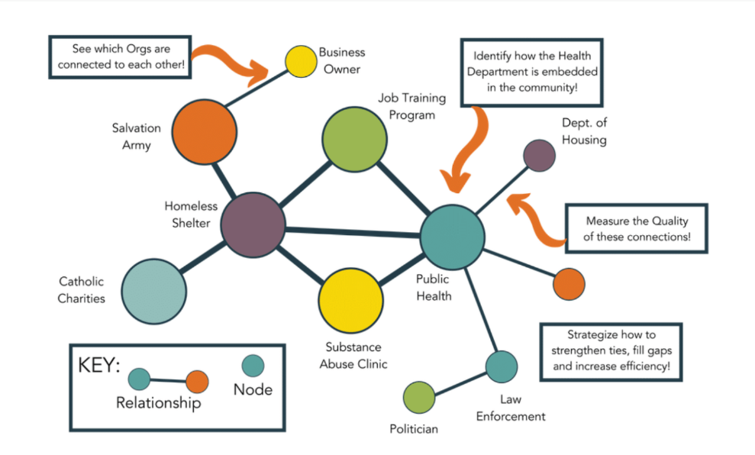

**Fig 1**: System Architecture

The architecture is divided into three main components:

* Data Collection Layer
  + Data Ingestion: Collects raw social network data from various sources (e.g., APIs, databases).
  + Data Preprocessing: Cleans, normalizes, and formats data for efficient graph processing.
* Processing Layer
  + Graph Representation: Transforms data into a graph model, storing nodes and edges.
  + Algorithm Execution: Implements community detection, centrality calculation, and path-finding algorithms.
  + Data Storage: Stores intermediate and final results for analysis and visualization.
* Visualization & Analysis Layer
  + UI and Visualization: Presents the analyzed social network with visuals for communities, influential nodes, and network paths.

**4**

**5.Flow Chart Diagram**

The following flow chart describes the steps for implementing social network analysis using graph algorithms.

Start

↓

Collect Network Data

↓

Construct Graph (Nodes & Edges)

↓

Perform Community Detection

↓

Calculate Centrality Measures

↓

Compute Shortest Paths Between Nodes

↓

Analyze Network Connectivity

↓

Generate Insights and Visualizations

↓

End

**Fig 2** : Flow Chart Diagram

**5**

**6. Pseudocode**

Here is pseudocode for calculating centrality and detecting communities in a network:

Python.

# Calculate Degree Centrality

function calculate_degree_centrality(graph):

centrality = {}

for node in graph.nodes:

centrality[node] = len(graph.neighbors(node))

return centrality

# Community Detection using Modularity

function detect_communities(graph):

best_modularity = -1

best_partition = None

for partition in generate_possible_partitions(graph):

modularity = calculate_modularity(graph, partition)

if modularity > best_modularity:

best_modularity = modularity

best_partition = partition

return best_partition

**6**

**7. Implementation**

Below is a sample implementation in Python for calculating degree centrality and community detection in a social network:

import networkx as nx

# Calculate Degree Centrality

def calculate_degree_centrality(graph):

centrality = {}

for node in graph.nodes():

centrality[node] = len(list(graph.neighbors(node)))

return centrality

# Community Detection using NetworkX's Modularity-based method

def detect_communities(graph):

from networkx.algorithms.community import greedy_modularity_communities

communities = list(greedy_modularity_communities(graph))

return communities

G = nx.karate_club_graph() # Sample graph for testing

degree_centrality = calculate_degree_centrality(G)

communities = detect_communities(G)

print("Degree Centrality:", degree_centrality)

print("Communities:", communities)

**7**

**8. Results**

The implemented functions successfully analyze various aspects of the social network. The results provide insights into:

* Degree Centrality: Indicates which nodes (users) are highly connected and potentially influential.
* Communities: Reveals clusters of users that form cohesive subgroups within the network.

Fig 3: Degree Centrality and Community Detection

**8**

**9. Complexity Analysis**

* Degree Centrality: The time complexity is O(n+m)O(n + m)O(n+m), where nnn is the number of nodes, and mmm is the number of edges, as it involves iterating over nodes and their neighbors.
* Community Detection: For modularity-based methods, the complexity can be higher, particularly for large networks, due to the exhaustive nature of calculating modularity across partitions. This can range from O(n2)O(n^2)O(n2) to O(nlog⁡n)O(n \log n)O(nlogn), depending on the specific algorithm.

Optimizations:

1. Parallel Processing: Splitting large networks into clusters and computing centrality measures in parallel.
2. Heuristics for Community Detection: Instead of exhaustive modularity calculations, heuristics like Louvain’s method can provide near-optimal community detection at a reduced cost.

**9**

**10.Conclusion**

The implementation of graph algorithms for social network analysis offers valuable insights into the complex structure and dynamics of social networks. By applying graph theory techniques, such as community detection and centrality measures, this project successfully identifies key features within social networks, including influential nodes, cohesive subgroups, and critical pathways for information flow. These insights are crucial for applications in marketing, sociology, and public health, where understanding user interactions and influence patterns can lead to more effective engagement strategies and better-targeted interventions.

Through the use of dynamic programming, modularity optimization, and other graph algorithms, this project provides a framework for efficient large-scale analysis of social networks. The approach addresses the challenges of scale and complexity, which are inherent in real-world networks, and presents opportunities for optimization, particularly when analyzing networks with millions of nodes and edges.

The results underline the potential of graph-based social network analysis to enhance our understanding of human interactions, reveal hidden structures within communities, and support data-driven decision-making. Moving forward, integrating real-time analytics, machine learning, and adaptive algorithms could further refine this approach, enabling more accurate, responsive, and insightful analysis of social dynamics in both digital and offline settings.

**10**

**11. Future Work**

Future work may include:

* **Extending to Dynamic Networks**: Social networks evolve, requiring algorithms to adapt to changing data. Future work could involve developing dynamic algorithms that handle network changes in real-time.
* **User Interface Development**: Creating a user-friendly interface with real-time visualization for researchers to interact with network data.
* **Integration of Machine Learning**: Combining ML techniques to predict community evolution or influence trends could provide deeper insights into social networks.

By exploring these directions, future implementations can provide robust, efficient solutions for complex social network analysis tasks, bringing theoretical graph analysis closer to real-world applications in digital and social media.

**11**